Reference: Building PHP Applications with Symfony, CakePHP, and Zend Framework
by Bartosz Porebski, Karol Przystalski and Leszek Nowak

OVERVIEW

Model-View-Controller (MVC) has been an important architectural pattern in computer science for many years. Originally named Thing-Model-View-Editor in 1979, it was later simplified to Model-View-Controller. It is a powerful and elegant means of separating concerns within an application (for example, separating data access logic from display logic) and applies itself extremely well to web applications. Its explicit separation of concerns does add a small amount of extra complexity to an application's design, but the extraordinary benefits outweigh the extra effort. It has been used in dozens of frameworks since its introduction. You'll find MVC in Java and C++, on Mac and on Windows, and inside literally dozens of frameworks.

WHAT IS MODEL-VIEW-CONTROLLER?
Model-View-Controller (MVC) is an architectural pattern used to separate an application into three main aspects:

- The Model: A set of classes that describes the data you're working with as well as the business rules for how the data can be changed and manipulated

- The View: The application's user interface (UI)

- The Controller: A set of classes that handles communication from the user, overall application flow, and application-specific logic

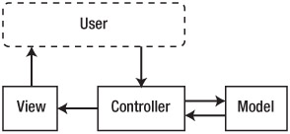

Ruby on Rails
Ruby on Rails (or Rails, as it's colloquially known) is arguably one of the most popular MVC frameworks ever created for the Web. It works according to two major guiding principles:

- Convention over Configuration: The idea is that as developers we've been doing web development for years now. Let's agree on the things that work and make that part of the framework.

- Don't Repeat Yourself, or Keep It DRY: This applies to centralizing the logic of an application as well as the code. If you keep this idea in mind, you'll find yourself writing a lot less code.

Rails also includes the concept of routing, mapping URLs to controllers via the config/routes.rb file. For example, this Rails command:

map.connect ': controller/: action/: id'

would route any URL with this general format to the appropriate controller action method, and pass along the ID as an argument.

Popular PHP MVC Frameworks

CodeIgniter
CodeIgniter is the first and simplest of the frameworks we will be looking into. It is developed and maintained by EllisLab and can be described as an open source (though, tightly controlled) framework that forms the base for EllisLab's premium CMS (Content Management System) ExpressionEngine.

Zend Framework
Zend Framework is an extensive collection of loosely coupled code libraries that can form the basis of an MVC architecture. Zend Framework takes quite a bit of effort to understand and master relative to other popular MVC frameworks. It is developed by Zend Technologies and enjoys all the benefits of a large, stable community and wide adoption.

CakePHP
CakePHP is arguably the most popular of the three frameworks. Unlike the previous two frameworks, it is not governed by any one corporate entity. It has a large community and is widely adopted.

It favors convention over configuration, which means a lot of the finer details are assumed and automated. This is apparent in every area of the framework, and you will often find yourself wondering how CakePHP is doing something you didn't ask it to do, both good and bad. This means you can develop an application quickly, but also that you might have a hard time when you need to make very specific changes.

Installation Requirements
In order to successfully build web applications with web frameworks you need the following server software:

- An HTTP server that accepts incoming connections and returns displayed websites
- A relational database based on SQL for persistent storage of all kinds of data
- A PHP interpreter to turn your PHP code into system calls, database queries, and dynamic web page content

OBJECT-RELATIONAL MAPPING
ORM is one of the core concepts of PHP frameworks. It creates an abstraction layer between relational database management systems (RDBMSs) and object-oriented business logic. There are specialized ORM-only frameworks that can be used alone in any PHP code or combined with Model- View-Controller (MVC) frameworks. The three frameworks provide the following ORM solutions:

- CakePHP — Uses its own integrated ORM solution. Other ORMs can also be used.
- Zend Framework (ZF) — Provides only some database access tools, but a full ORM third- party framework can be easily installed. Future versions will integrate Doctrine by default.

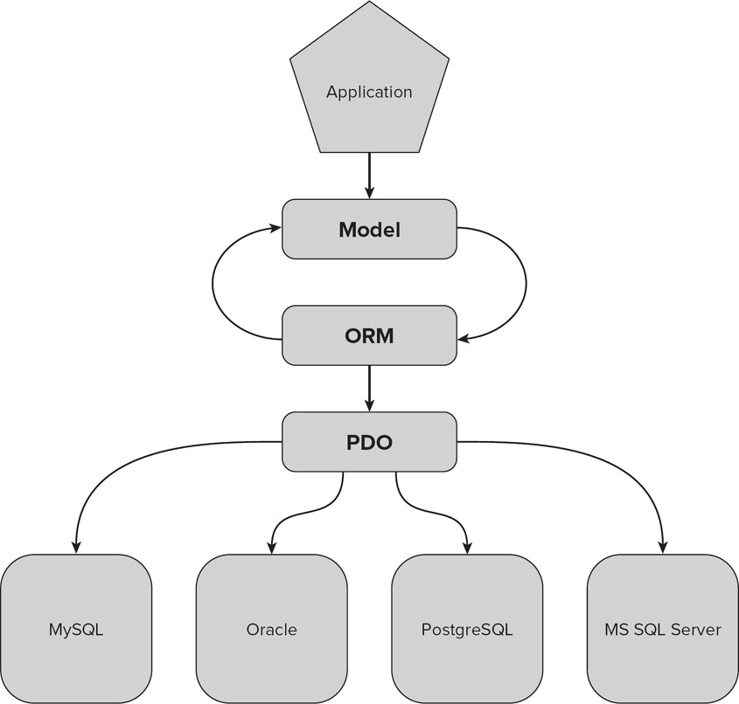

DEVELOPING AN ONLINE ADDRESS BOOK APPLICATION USING MVC

CAKEPHP

Before you start building an application, you should make sure that the database you are working with is properly created for this purpose. This project will use a database that is named Cake, and this database should contain one table called addresses.

/cake_installation
/app
/config
routes.php
database.php
core.php
/controllers
addresses_controller.php
/models
address.php
/views
/addresses
add.ctp
edit.ctp
index.ctp
view.ctp

Routing
If you would like to access your address book project by typing http://localhost/cake/the-book in the browser, what you need to do now is to add an instruction to the CakePHP routing file that will make that URL point to the proper controller and its functions. To do this, it is necessary to edit the routes.php file and add another line:
Router::connect('/the-book',
array('controller' => 'addresses',
'action' => 'index'));

Model
Now it's time to create the model for the project. It should be located in the /models directory (“address.php”). It needs to look like this:
<?php
class Address extends AppModel {
var $name = 'Address';
}
?>

Schema
You can run CakePHP commands to build a database using a schema defined in /cakephp/app/config/schema/schema.php:

var $_schema = array(
'id' => array('type' => 'string', 'length' => 30),
'first_name' => array('type' => 'string', 'length' => 30),
'last_name' => array('type' => 'string', 'length' => 30),
'email' => array('type' => 'string','length' => 30),
'phone' => array('type' => 'string','length' => 30),
'address' => array('type' => 'text'),
'created' => array('type' => 'date'),
'modified' => array('type' => 'date')
);

Controller
/cakephp/app/controllers/addresses_controller.php:
<?php
class AddressesController extends AppController {
var $name = 'addresses ';
}
?>
Naming conventions in CakePHP are applied to make the use of the Model-View-Controller (MVC) as easy as possible. In your address book, the controller will be used to handle actions performed on data (addresses) that your address book will contain. Knowing this, you will need to name your controller addresses. As you know, CakePHP will automatically try to look for a model to connect with. The model's name is singular, unlike the controller's file and views' folder names. Therefore, if you want to use the automatic functions of the CakePHP framework, you need to use plural names for the controller, database tables, and views folders. Singular names will be used only for the model.

List of All Addresses
To create this action, add a function index inside the brackets of the addresses controller (“/cakephp/app/controllers/addresses_controller.php”):
class AddressesController extends AppController {
var $name = 'addresses';
function index($id = null) {
$this->set('address_list', $this->Address->find('all'));
}
}

This action finds all addresses available in your database. It is the same as this SQL query:

SELECT * FROM addresses;
That way, whenever someone types http://localhost/cake/the-book into a web browser window, an index() action will be called, and all data contained in addresses table will be read and saved into the address_list variable. The set() method used in this example creates a variable (in this case, it is address_list) and assigns data to it (here it is a list of all addresses) so later it can be read and used in a view template to display its content.

Note that for every controller method that is supposed to display something, a view file should be created (index.ctp, add.ctp, and so on).

Adding a New Address
Putting function add() into the addresses_controller.php file should get you where you want to go. The following code will handle adding new addresses to the database:
function add() {
if (!empty($this->data)) {
if ($this->Address->save($this->data)) {
$this->Session->setFlash('New address has been saved.');
$this->redirect(array('action' => 'index'));
}
}
}

Editing an Address
Because you now have a list of all addresses and can add new addresses, you can move on to editing entries. To do so, you will add another action to the addresses controller and create a new view file. Add the edit() function as follows:
function edit($id = null) {
$this->Address->id = $id;
if (empty($this->data)) {
$this->data = $this->Address->read();
} else {
if ($this->Address->save($this->data)) {
$this->Session->setFlash('New address has been saved.');
$this->redirect(array('action' => 'index'));
}
}
}

This function is very similar to the add() function and is divided into two sections. The first section is responsible for loading selected address information into data ($this->data) that will be displayed by an edit form. The second section is responsible for saving submitted form data into the database. This is intuitive because you use the edit() method to display and save entry data. The first if statement determines whether you want to display the data or save it. As you can see, all GET data that you want to get is intercepted as method parameters.

Deleting a Selected Address
Now that you have created most of the application's functionality, the last thing to do is add the delete option. Add the new delete() action as follows:
function delete($id) {
$this->Address->delete($id);
$this->Session->setFlash('Address with id: '.$id.' has been deleted.');
$this->redirect(array('action'=>'index'));
}

As before, this file uses most of the framework's functionality, and by running $this->Address->delete($id), it removes every entry with the given ID from the database without writing any database queries. The next line generates a message to be displayed after redirection is done.

Viewing a Selected Address
This is the most obvious and simplest task. As before, you need to add a new action to addresses_ controler.php according to the following code:
function view($id = null) {
$this->Address->id = $id;
$this->set('address', $this->Address->read());
}

View
Address List
To display all data from the database, use an HTML table in the /cakephp/app/views/addresses/index.ctp:
<table>
<tr>
<th>Id</th>
<th>First name</th>
<th>Last name</th>
<th>Email</th>
<th>Phone</th>
<th>Address</th>
<th>Options</th>
</tr>
<?php
foreach ( $address_list as $line ) {
$address = $line['Address'];
echo
'<tr>'.
'<td>'.$address['id'].'</td>'.
'<td>'.$address['first_name'].'</td>'.
'<td>'.$address['last_name'].'</td>'.
'<td>'.$address['email'].'</td>'.
'<td>'.$address['phone'].'</td>'.
'<td>'.$address['address'].'</td>'.
'<td></td>'.
'</tr>';
};
?>
</table>

You can see all addresses saved to the database through the Add New Address form. You get all data in the $address_list.

Now you have all the prerequisites to fill the add view file. Add a link to the top of index.ctp:
<?php
echo $html->link('Add new address', array('action'=>'add'));
?>

You can now see the results of your work. It is not much, but typing http://localhost/cake/the-book into a web browser window should display your index page. Here you can see the standard CakePHP header and footer, as well as the content created by us, which should be a single link called Add New Address. This link, if clicked, will call the same controller, but a different action, which in this case will be the add action.

Forms
Adding forms in CakePHP is very simple. This framework creates all needed input fields for a given model. The necessary code is shown as follows (“/cakephp/app/views/addresses/add.ctp”):
<?php
echo $form->create('Address');
echo $form->inputs();
echo $form->end('Save address');
?>

Note that only three form methods were used: form starting and ending tag methods, and an input generation method. The last method generates all needed input files. This is a time-saving approach because it gets the create() parameter, which is in fact the name of the model and automatically returns all needed input fields based on model information. You might wonder why the two additional methods are necessary. The answer is that they're needed because the HTML form tag can be customized, as can the submit button.

Editing an Address
To edit an entry, you need to add a proper link that will redirect you to the edit form page. To do that, you need to edit index.ctp and change it a little bit, as shown in the following code(“/cakephp/app/views/addresses/index.ctp”):
<?php
foreach ( $address_list as $line ) {
$address = $line['Address'];
echo
'<tr>'.
'<td>'.$address['id'].'</td>'.
'<td>'.$address['first_name'].'</td>'.
'<td>'.$address['last_name'].'</td>'.
'<td>'.$address['email'].'</td>'.
'<td>'.$address['phone'].'</td>'.
'<td>'.$address['address'].'</td>'.
'<td>'.$html->link('edit',
array('action'=>'edit',
'id'=>$address['id'])).'</td>'.
'</tr>';
};
?>

The link() function added in this template has two parameters. The first is the text that will be displayed as a link, and the second is an array that allows you to set various parameters, such as the action name that will be called when the generated link is clicked and the id parameter that will be passed by the $_GET variable to identify which address will be edited.

At this point, the edit action is still missing a view file, so create one “edit.ctp” as follows:
<?php
echo $form->create('Address', array('action' -> 'edit'));
echo $form->inputs();
echo $form->end('Save address');
?>

The Edit Address form is generated by the file that you have just created and looks identical to the form that handles adding new addresses, except that it contains the data of a selected address rather than being blank.

Viewing a Selected Address
Now create a view that will allow you to see detailed address information using a custom view. The most intuitive approach is to click an address entry from the address list. To do this, change the index.ctp file again:
<?php
foreach ( $address_list as $line ) {
$address = $line['Address'];
echo
'<tr>'.
'<td>'.$address['id'].'</td>'.
'<td>'.$html->link($address['first_name'],
array('action'=>'view',
'id'=>$address['id'])).'</td>'.
'<td>'.$address['last_name'].'</td>'.
'<td>'.$address['email'].'</td>'.
'<td>'.$address['phone'].'</td>'.
'<td>'.$address['address'].'</td>'.
'<td>'.$html->link('edit',
array('action'=>'edit',
'id'=>$address['id'])).'</td>'.
'</tr>';
};
?>

The added line works the same way as when you added an edit link. It makes the first_name value clickable and allows it to call the view action that will display the following file, which you need to create in the /views folder (“/cakephp/app/views/addresses/index.ctp”):
<?php
$address = $address['Address'];
echo $html->link('Back to list', array('action'=>'index'));
echo '<h1>'.$address['first_name'].' '.$address['last_name'].'</h1>'.
'<p>Email: '.$address['email'].'</p>'.
'<p>Phone: '.$address['phone'].'</p>'.
'<p>Street: '.$address['street'].'</p>'.
'<p>Address: '.$address['address'].'</p>';
?>

Deleting an Entry
Now that the code responsible for deleting entries has been created, modify the index.ctp file in the /views directory so that it allows you to select an entry for deletion.
<?php
foreach ( $address_list as $line ) {
$address = $line['Address'];
echo
'<tr>'.
'<td>'.$address['id'].'</td>'.
'<td>'.$html->link($address['first_name'],
array('action'=>'view',
'id'=>$address['id'])).'</td>'.
'<td>'.$address['last_name'].'</td>'.
'<td>'.$address['email'].'</td>'.
'<td>'.$address['phone'].'</td>'.
'<td>'.$address['address'].'</td>'.
'<td>'.$html->link('edit',
array('action'=>'edit',
'id'=>$address['id'])).
' '.$html->link('delete',
array('action'=>'delete',
'id'=>$address['id'])).'</td>'.
'</tr>';
};
?>

Web Services Overview

Web Service is the programmable application logic accessible via standard Web protocols. There are two important points in this definition:
- Programmable application logic. Web Service is implementation-non-specific. The application logic can be implemented by components, by Perl scripts, or by any other mechanism that supports XML.
- Standard web protocols. Web services use Internet transport protocols such as HTTP.

It's a diverse world. In a major enterprise, very rarely do you find that the entire organization and its data repositories reside on a single vendor's platform. In most instances, organizations are made up of a patchwork of systems — some based on Unix, some on Microsoft, and some on other systems. There probably won't be a day when everything resides on a single platform where all the data moves seamlessly from one server to another. For that reason, these various systems must be able to talk to one another. If disparate systems can communicate easily, moving unique datasets around the enterprise becomes a simple process — alleviating the need for replication systems and data stores.
When XML (eXtensible Markup Language) was introduced, it became clear that the markup language would be the structure to bring the necessary integration into the enterprise. XML's power comes from the fact that it can be used regardless of the platform, language, or data store of the system using it to expose DataSets.
XML has its roots in the Standard Generalized Markup Language (SGML), which was created in 1986. Because SGML was so complex, something a bit simpler was needed — thus the birth of XML.
XML is considered ideal for data representation purposes because it enables developers to structure XML documents as they see fit. For this reason, it is also a bit chaotic. Sending self-structured XML documents between dissimilar systems doesn't make a lot of sense — you would have to custom build the exposure and consumption models for each communication pair.
Vendors and the industry as a whole soon realized that XML needed a specific structure that put some rules in place to clarify communication. The rules defining XML structure make the communication between the disparate systems just that much easier. Tool vendors can now automate the communication process, as well as provide for the automation of the possible creation of all the components of applications using the communication protocol.
The industry settled on using SOAP (Simple Object Access Protocol) to make the standard XML structure work. Previous attempts to solve the communication problem that arose included component technologies such as Distributed Component Object Model (DCOM), Remote Method Invocation (RMI), Common Object Request Broker Architecture (CORBA), and Internet Inter-ORB Protocol (IIOP). These first efforts failed because each of these technologies was either driven by a single vendor or (worse yet) very vendor- specific. It was, therefore, impossible to implement them across the entire industry.
SOAP enables you to expose and consume complex data structures, which can include items such as DataSets, or just tables of data that have all their relations in place. SOAP is relatively simple and easy to understand. Like ASP.NET, XML Web services are also primarily engineered to work over HTTP. The DataSets you send or consume can flow over the same Internet wires (HTTP), thereby bypassing many firewalls (as they move through port 80).
How Does REST Work?
REST is very simple and based on HTTP request methods: GET, POST, DELETE, and PUT. You probably remember the first two methods from developing previous example applications. The last two methods are not so popular in common application development, but PUT and DELETE can be used in the same way as POST and GET. GET is used every time you use an Internet browser in the usual way to gather web content. POST is commonly used when some data needs to be sent to an application. It's used in almost all web forms. REST is based on all four methods to implement a create, read, update, and delete (CRUD) application without filling any forms, but just by simple method-invoking. Comparing REST to CRUD operations, GET would be read, POST would be create, DELETE would be delete, and PUT would be update.

What is the Difference between SOAP and REST?
SOAP:
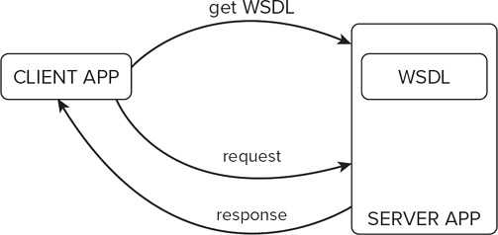
REST:
